24F Client-Side JavaScript – 200

Week12-InClass-LabActivity

Student: Geraldo Beiro

Student ID: 200587023

**1 - NASA MARS ROVER PHOTOS API** (Personal Choice):

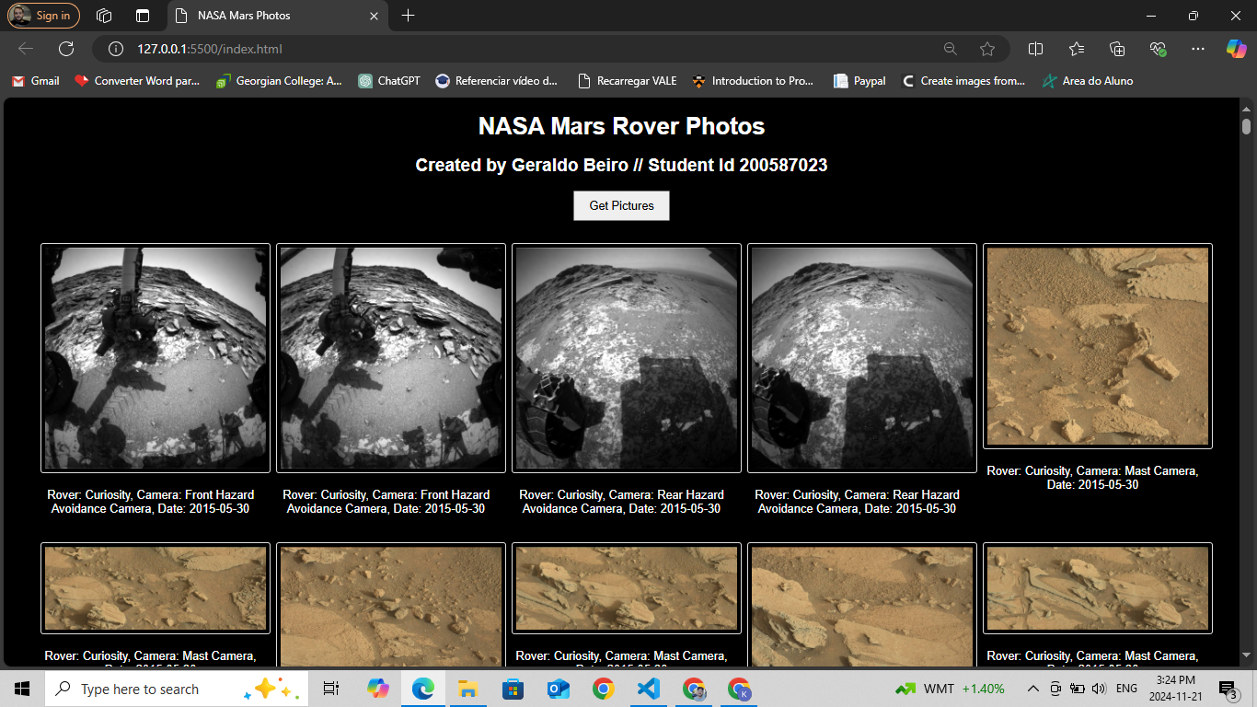

**2 – POKEMON CARD GENERATOR API:**  
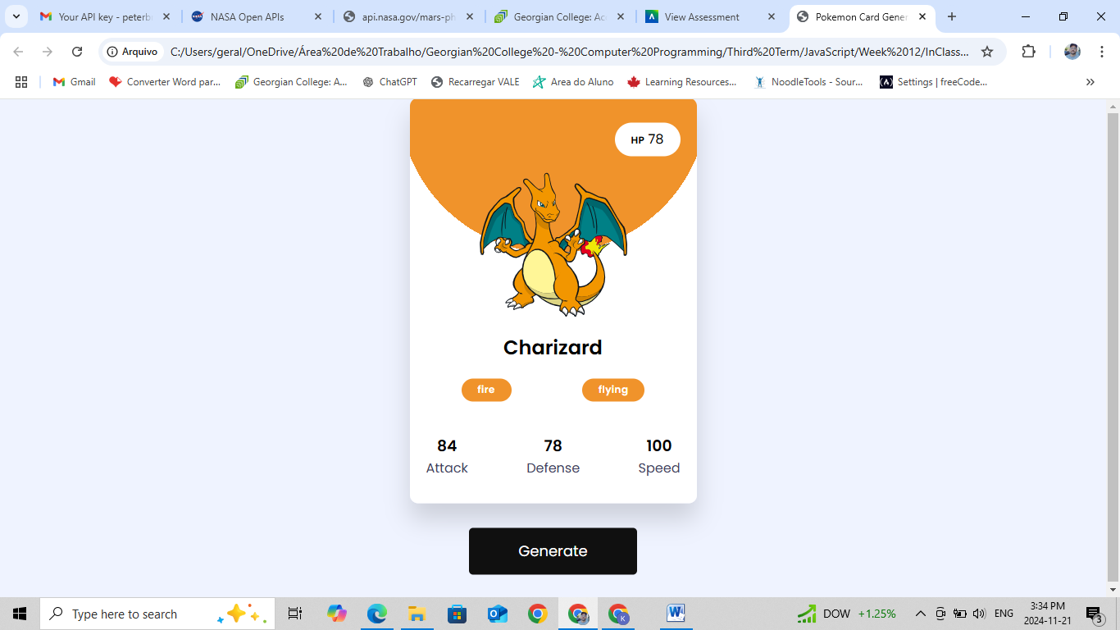

**3 – COUNTRY GUIDE API:**  
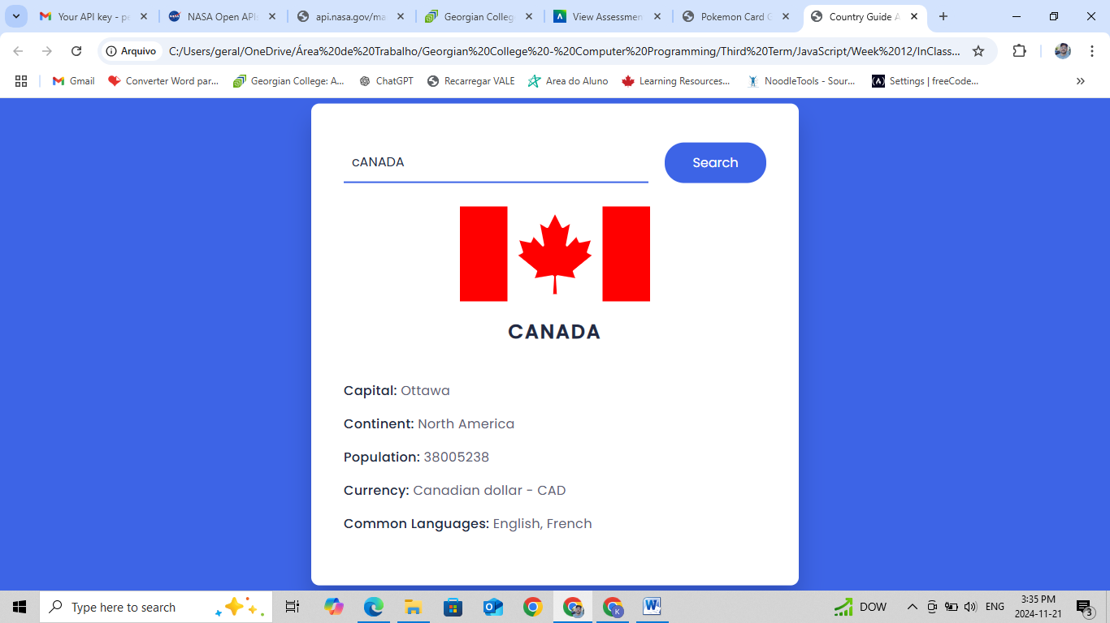

**4 – MOVIE GUIDE:**  
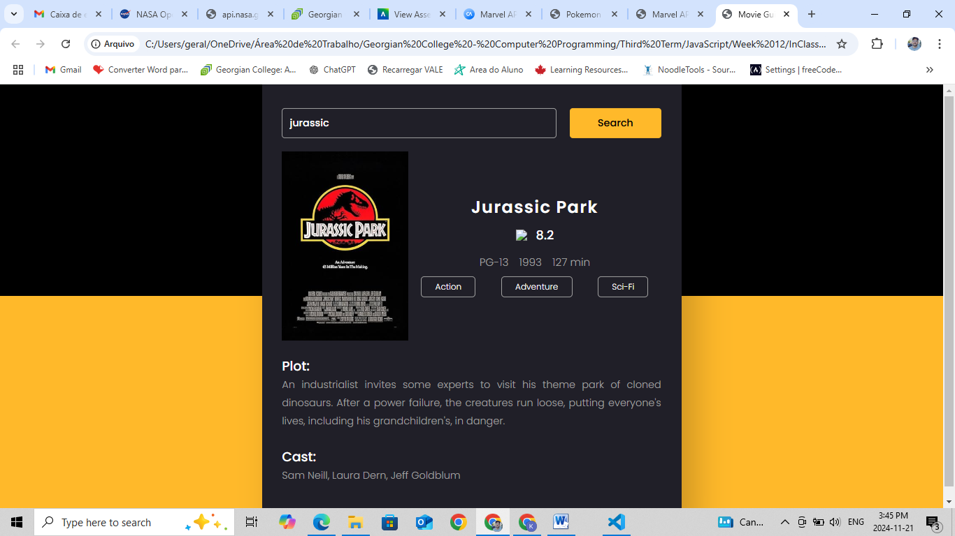

**5 – TIC TAC TOE:**  
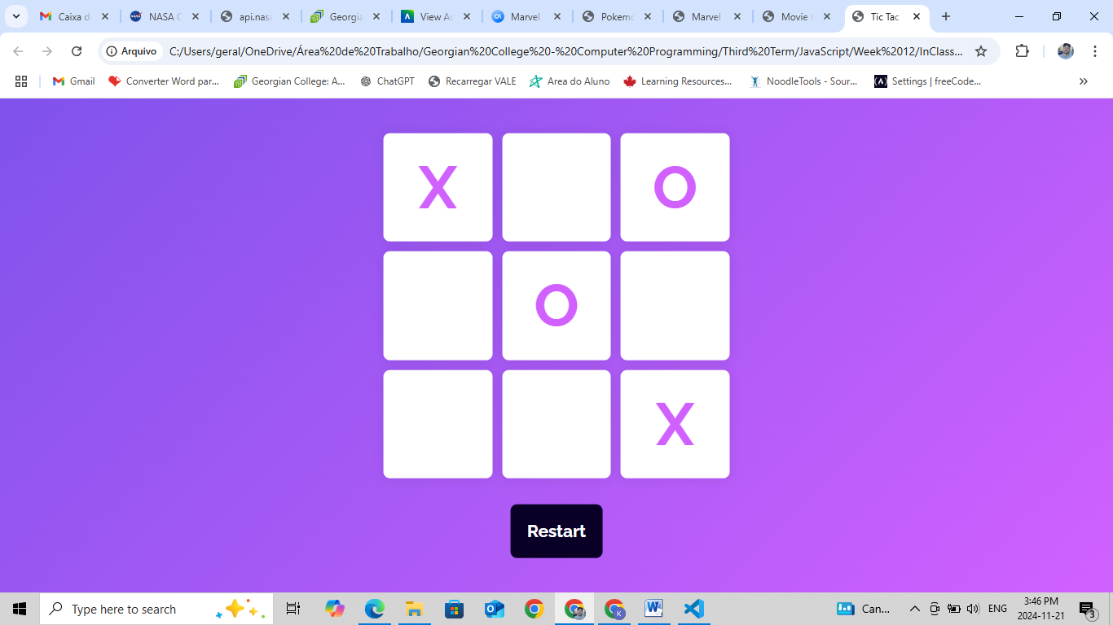

**6 - RECIPES**:

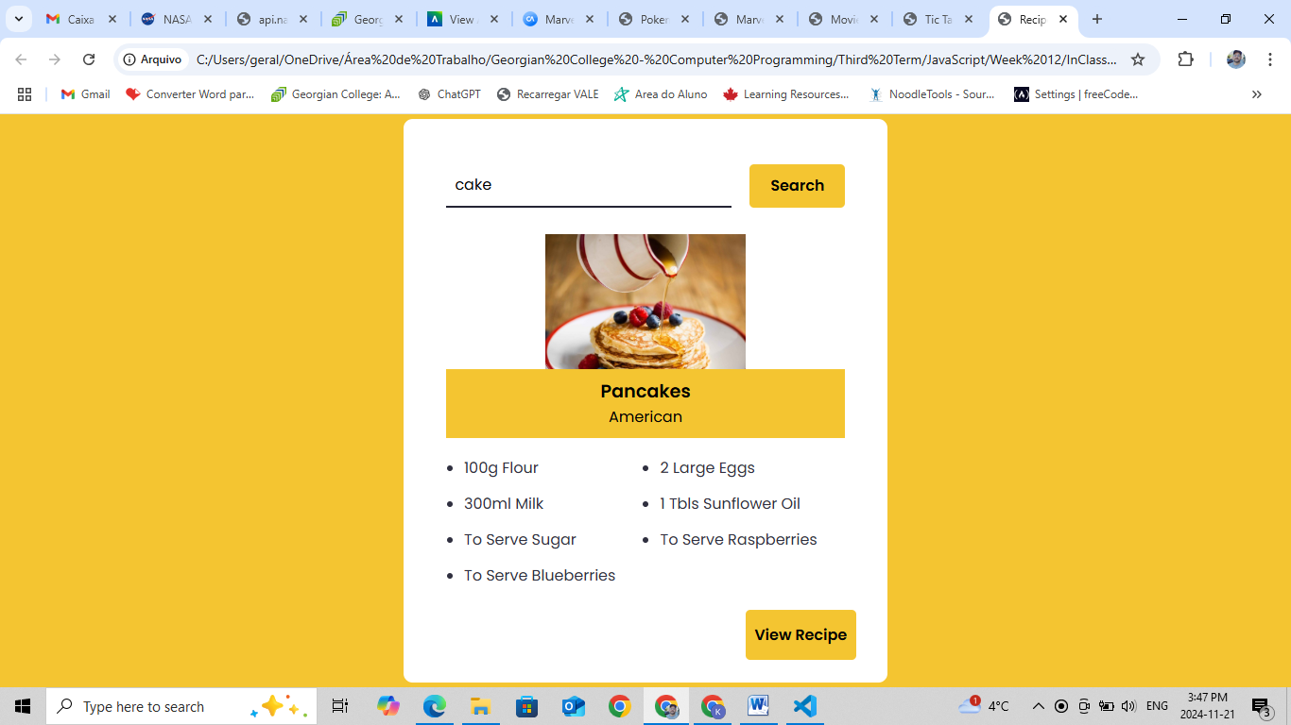

**7 – RANDOM JOKE**

